# Overall Design Document

**for Music Recommendation System**

Revision History:

|  |  |  |
| --- | --- | --- |
| Date | Author | Description |
| 2020-08-27 | Jingze Yang | Version_0 |
| 2020-09-08 | Jingze Yang | Version_1.0 |
|  |  |  |

**Overall Design**

**1.1 Requirement overview**

Music recommendation System aims to track user’s favorite labels of music and songs added to user’s personal center to provide user’s with the most suitable songs for them. It has a UI to allow users to experience these functions.For more details on the usage and capabilities of the application read the section,[System Capabilities](https://uocis.assembla.com/spaces/cis422w18-team2/wiki/Software_Requirements).

**Main function**

1. Register:Users register with username and key.
2. Login:Users login with username and account.
3. Choose labels:Users choose their favorite music labels.
4. Search music:Users search songs on the web.
5. Hot music list:System show hot music in this period.
6. Add music:Users add music to personal center.
7. Recommend music:System recommend music to users.
8. Song List:Personal center show all added songs.
9. Song Information:Users click songs and see their information.

**1.2 Environment**

OS：Windows 7、Windows 10、Mac OS

**1.3 Overall Structure**

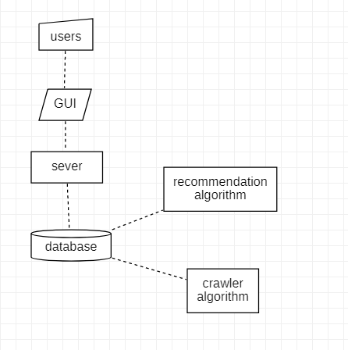

**Database Design**

* 1. User Information

Store information of users

|  |  |  |
| --- | --- | --- |
| **name** | **format** | **explain** |
| uid | int | User id |
| uname | varchar(20) | User name |
| msg | varchar(16) | User key |
| label | varchar(50) | Favorite labels |

## 

* 1. Song Information

Store information of music

|  |  |  |
| --- | --- | --- |
| **name** | **format** | **explain** |
| cid | int | Music id |
| cname | varchar(50) | Music name |
| singer | varchar(20) | Music singer |
| mid | int list | Song list id |
| label | varchar(50) | Label |

## 

* 1. Song Lists

Store information of song lists

|  |  |  |
| --- | --- | --- |
| **name** | **format** | **explain** |
| gid | int | List id |
| gname | varchar(50) | List name |
| label | varchar(50) | Label |

## 

* 1. Individual Song Lists

Store information of individual song lists

|  |  |  |
| --- | --- | --- |
| **name** | **format** | **explain** |
| mid | int | Click id |
| uid | int | User id |
| sig | int | Music id |
| t | datetime | Click time |